**ESS 132 Week 4 Discussion tasks**

1. What phase of snowmelt takes the longest amount of time? Why?

The output phase. It takes longer than the warming phase because it uses the heat of fusion as opposed to the specific heat of ice, and there tends to be a very large energy change associated with melting ice as opposed to raising the temperature of ice. It is also larger than the ripening phase because the ripening phase uses h­wret, which is the height of only a small part of the meltwater and tends to be scaled down using ϴret. The output phase uses the difference between the height of the meltwater and h­wret, and this difference tends to be larger than hwret, resulting in a larger amount of heat needed to complete the output phase and therefore a longer amount of time.

1. How would you expect streamflows to change in California over the next 50 years and why?

Streamflow would be more intense over the winter. California gets most of its precipitation during the winter. With climate change, the precipitation type is expected to shift more over to rain, which would cause immediate increases in streamflow during the winter. This precipitation shift would cause snowpacks to decrease, and since snowpacks are the primary source of streamflow during the summer, this would cause decreases in streamflow during the summer. This precipitation shift would cause more flooding during the winter, as the increased streamflow is more likely to flood our reservoirs and streams. To counteract, we would open our reservoirs to increase outflow, which means that we would end up wasting more water. The decrease in streamflow over the summer would hamper our water supply when water demand tends to be at its highest due to agriculture occurring during the summer.

1. Describe and explain the similarities and differences between these 2 maps of ET.

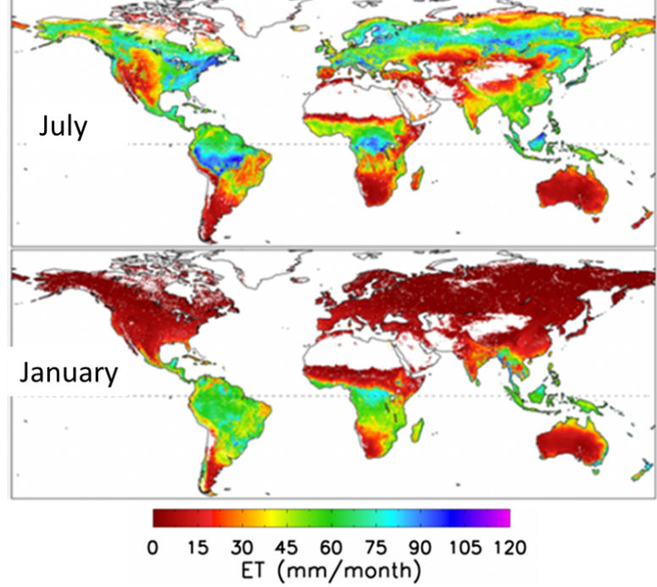

Source: MODIS

ET tends to be fairly constant around the equator. The constant presence of the ITCZ supplies the tropics with a constant source of precipitation, which results in fairly constant ET. There also tends to be fairly low ET around the edges of deserts such as the Sahara Desert and the Gobi Desert.

One very dramatic difference is that ET is lower in the Northern Hemisphere during January. The Northern Hemisphere is in the middle of winter during January when sunlight tends to be very diffused, which results in lower temperatures that causes less evaporation to occur. In addition, forest ecosystems, which is the main ecosystem over the areas of the Northern Hemisphere that exhibit these changes, tend to decrease or stop their biological activity during the winter as decreases in temperatures and sunlight hampers photosynthesis.